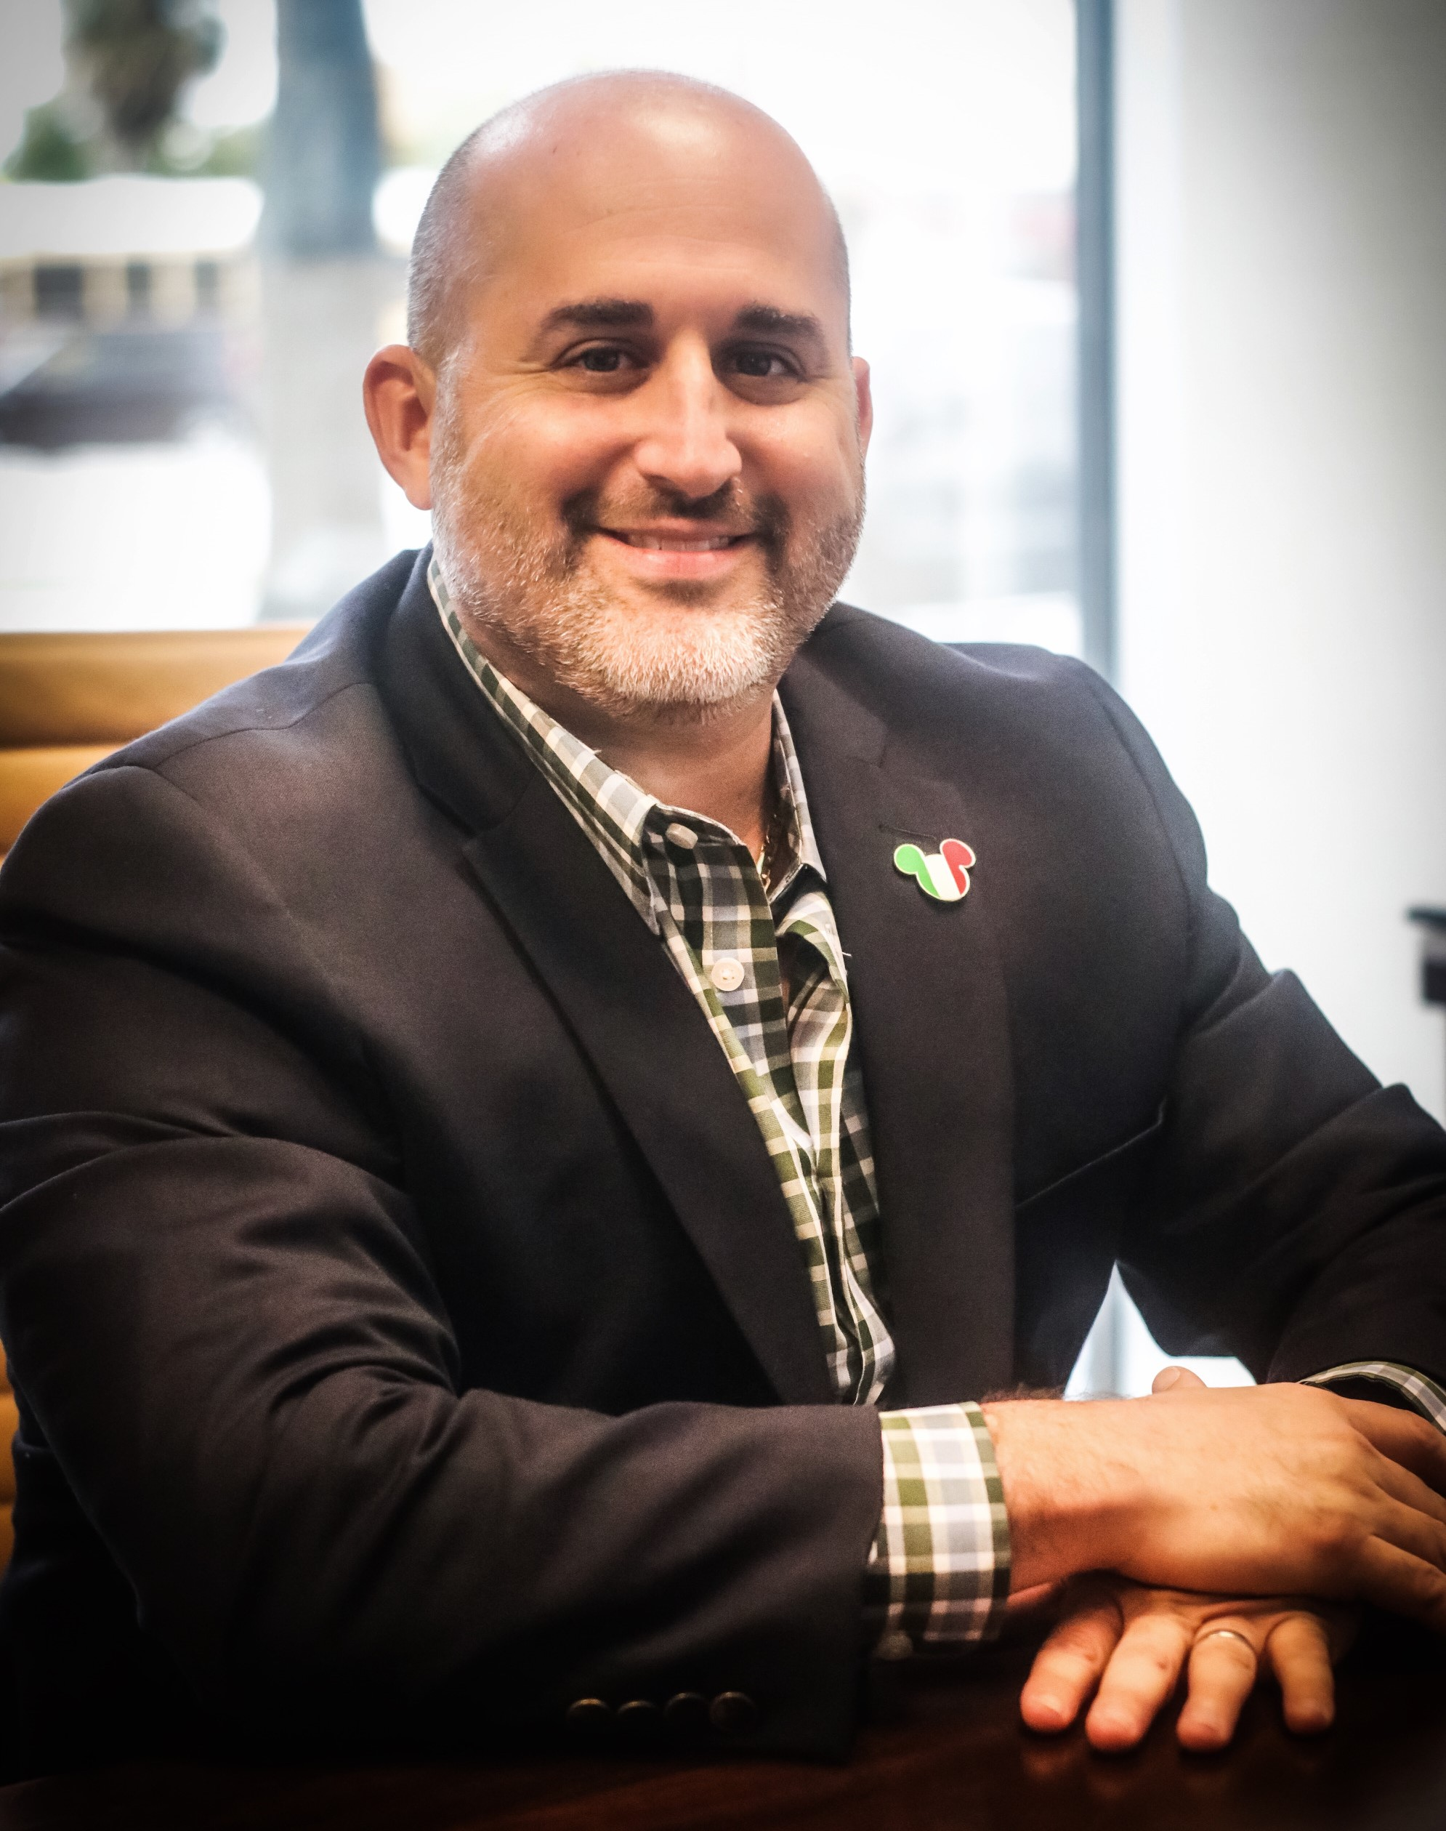 |  | Jason Weinrub,  C.P.A.  Managing Member
Profile  A Certified Public Accountant with over 20 years’ experience.  Providing consulting services to businesses and individuals ranging in size from start-ups to $200 million in revenue. Serving domestic and international clients across a broad range of industries.  Specializing in tax compliance, bookkeeping and due diligence services related to mergers and acquisitions with industries from wholesale/distribution to telecommunications. I also provide multi-state tax compliance matters with closely held companies.  Contact  PHONE:  954-744-8440  WEBSITE:  https://theflacpa.com/  EMAIL:  jweinrub@theflacpa.com  skills  - Tax Accounting  - Auditing  - Mergers & Acquisitions  - Financial Reporting |  | EDUCATION  Florida Atlantic University  Master of Accounting, 2005  University of Miami  Bachelor of Business Administration in Accounting, 1999  WORK EXPERIENCE  Rosenbaum Sobel Weinrub LLC – Managing Member  2020–Present  JBW CPA, Inc – President  2017–2020  MBAF – Senior Manager  2005–2017  Koch Reiss – Senior Associate  2004–2005  McGladrey – Staff  2001–2004  Certifications and Mamberships  Florida Certified Public Accountant, August 1982  American Institute of Certified Public Accountants  Florida Institute of Certified Public Accountants

